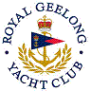 | Royal Geelong Yacht Club Inc.  Est 1859
Trophy Deed of Gift.

Trophy: | The Paddle
Presented by: | R. Robbins(subject to much debate)
Date: | 1967
For: | Selected by a panel of pseudo experts, the member who exhibits the best ability as a stirrer.
Remarks / Revisions | Can not be won by any person more than once

